The Mentoring Role of the Pastor/Leader

and the Church Governing Board

I remember conducting my first local church Board two-day planning retreat. What a blessing for me! The retreat format was built around “Characteristics of Strong and Effective Board Members.” Upon completing the retreat, a board member shared with the group that “we have a year of work as a board outlined for us this weekend.” It dawned on me in that retreat setting the mentoring role a leader has in relation to his/her governing board. Since that retreat years ago, I have given significant time to both the characteristics of strong and effective local church boards, and also to the ways in which pastors can intentionally mentor and develop the boards they together they seek to be more efficient and effective for mission accomplishment.

Permit me to share with you a foundational working assumption regarding my perspective on governing boards of faith of local churches:

STRONG BOARDS EMPOWER MISSIONAL AND VISIONARY PASTORS,
STRONG PASTORS EMBRACE PASSIONATE AND ENGAGED BOARDS.

Let’s work through the some of the implications of this assumption.

A “characteristic” of strong and effective boards is given below in each section, with an accompanying “best practice” for each characteristic. This section is developed more fully in the book, Best Practices for Effective Boards, published by Beacon Hill Press of Kansas City, and available on Amazon for downloading. Strong and Effective boards function in the embrace and affirmation that both strong pastor/leaders and strong boards are vital and required for local congregations to fulfill their mission and realize their vision in the communities wherein God has placed them.

Characteristics of Strong and Effective Boards

#1. Board members understand the role, purpose, and function of the board.
Focus on policy formulation and mission strategy, not daily operations and implementation

#2. Board members know, communicate, and make decisions in light
of the church’s mission, vision, and values.
Mission, Vision, and Values Drive us

#3. Board members ask the right questions.
Think Questions

#4. Board members understand and embrace a board policy manual that contains the board-approved policies for effective and efficient legal, financial, and policy governance of the local church.
Write It Down

#5. Board members communicate with each others and address conflict situations as Christians.
Watch Your Words

#6. Board members relate to their leaders and constituency with one voice.
Character Counts, Really Counts!
(Keep confidential conversations, confidential!)

#7. Board members intentionally engage in mutual accountability, including systematic board development and evaluation.
Board Integrity Matters!

#8. Board members take time to process decisions, with intentional surprises.
Take Time

#9. Board members embrace change and resolve to work through transitions and unite for the good of the Kingdom and the advancement of God’s mission.
Yes! To Missional Change

#10. Board members participate in assessing the effectiveness of prior decisions.
Review/Revise/Redirect/Renew

#11. Board members are outstanding examples of giving regularly and sacrificially to the church, college, or organization they serve.
Role Models of Generosity and Stewardship

#12. Board members develop new leaders for increased responsibilities and commitment throughout the church, college, or organization
Pass It On!

How would you modify this list with additions or deletions to make these “characteristics” a mentoring outline to guide you as you work with your board? List below the top three “characteristics” or “best practices” you desire for the board with whom you work to focus during the next six to eighteen months.

1.

2.

3.

Recently I asked pastors and local church boards during a BoardServe tour to think about a local church board vision statement. I encouraged them to think about a statement that would give their boards a “big picture” of why they do what they do. Why do they work regularly on the seemingly routine and mundane work of the local congregation? For what purpose? To what end do “our” efforts lead? What characterizes a board at its best? I suggested the following statement as a starting point:

“The leadership ministry of the church board enables
church attendees to fulfill their ministry to each other,
and the church’s mission and vision in the neighborhood and beyond”

How would you adapt this statement to the local church board on which you serve? Do you “see” in the statement a way of boards “viewing” themselves and the work they do our a regular basis? What difference on your board would a conscious “vision” of themselves as a leadership team, working with the pastor, in enabling the people who call the local congregation they serve as their faith community? And, everything that is done in a board meeting serves to facilitate, equip, and enable these individuals in the Christian ministry to each other, and their participation in the church’s mission, which is rally the mission of God, in your neighborhood and beyond?

“Govern Diligently”

In the fascinating 12th chapter of Romans, two words jump out at me as I think about governing boards of local churches. The words from 12:8 are “govern diligently.” “We have different gifts; according to the grace given to us….If it is leadership, let him govern diligently.” Romans 12:6-8b (NIV).

What does it mean to “govern diligently?

In various countries where I work with local church, school, and and ministry organization boards, I discover much ambiguity regarding board governance. Board members want to make a positive impact on the boards to which they belong. These individuals and the boards on which they serve want to make a significant difference. They are thrilled to be asked to serve on a board of governance.

For many, the invitation provides an opportunity to be good stewards of the gifts, talents, education and experiences with which they have been blessed. Often, however, this excitement soon leads to frustration as the boards on which they serve - local churches, colleges, seminaries, universities, district and national boards, and ministry organizations - lack an understanding of the role, purpose, and structure of the board to required to “govern diligently.”

The big question regarding governing boards is this: “What should a local church, ministry organization, or seminary governing board do to be a strong and effective board who “governs diligently…and effectively?”

In a video recently produced on “Building Better Boards,” I define a governing board as… “
“…an elected body that oversees the ministry and mission of a local church or ministry organization between annual membership meetings.” A governing board of a local church or a ministry organization “is guided by the Church Manual and/or ministry organization Bylaws and Articles of Incorporation,” and must insure that the legal documents and policy documents are up to date.

Organizations, including local churches, evolve and change. So must their governing boards. Strong and effective boards receive recommendations from the church or organization membership; boards also shape strategic recommendations for the full membership to consider. Strategic thinking, planning and implementation are key responsibilities of a governing board that “governs diligently.”

Change is inevitable – change in demographics, expectations, economics, technology, government, and education –just to name a few. Problems arise in the transitions. How do we adjust to the facts, context and trends we face in the changing community, country or region in which we work and serve?

Understanding transitions is important for boards. How we manage the transitions can facilitate or derail the increased influence and impact, and the expanded enrollment growth we desire and envision for the local church we love and serve.

Growing local churches need strong and effective governing boards in order to identify new initiatives and clarify the vision needed for increased influence and impact, and for expanded enrollment growth. Otherwise, decline will be the result.

Strong boards encourage passion and engagement by the members. They ask thoughtful questions, but do not attempt to "micro-manage" the local church. They respect their pastors because as an effective governing board they have nominated or elected the very strongest, "mission fit" leaders possible. These pastors know, communicate, make decisions, and submit recommendations to the board with a laser beam commitment to the church's mission, vision, and values. They have earned the trust of their boards and work in cooperation with them.

Likewise, strong pastors “lead” by bringing out the best in board members, listening to them and providing significant opportunities for them to engage in the decision making process. These leaders are not intimidated by probing questions. They take time to process questions in need of answers; challenges in need of decisions. No “intentional” surprises by board members or board leaders. These leaders model a commitment to communicate with each other and address conflict situations as Christians.

To lead, and be effective as a governing board, means to function appropriately in the three modes of board governance: the FIDUCIARY mode, the STRATEGIC mode, and the REPRESENTATIVE mode. This means that the board has governance and coordinating responsibility for the local church in at least the areas of:
1. Mission and Vision clarity 2. Strategic thinking and planning.
3. Financial health and legal standing 4. Budget approval and oversight
5. Mission implementation strategy and review
6. Curriculum consistency 5. Denominational connectivity
Let’s go deeper by asking several additional questions:
- What one word would you use to characterize the board on which you serve?
- What are the major strengths of this board?
- What is the most critical issue or major concern facing the board?
- What one board-related question would you like answered?.
5. Are the legal documents up to date, and readily available to board members?
6. What three big ideas should the Board focus on for the next three years?

7. In light of the “Lifespan and stages of a faith community” graph, what has changed significantly in the community surrounding the local church you serve to which the board must adjust and recommend or make appropriate transitions?

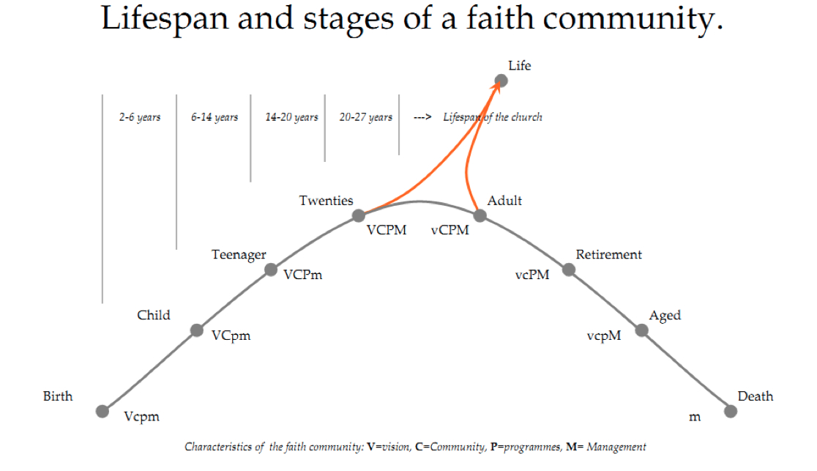

These “big questions” can only be asked and thoughtfully discussed if the board agenda has been intentionally developed. Guard the board agenda! Significant reports are important. So are the blocks of time needed to discuss the big questions facing the church.

Cultivate the discipline to “think questions.” Not just any questions. Strong and effective boards ask the right questions. The questions asked above are examples of basic, on-going questions that probe the big issues and help define the real problems.

At the beginning of this board development presentation, the convictional statement was expressed that “Strong boards empower missional and visionary leaders; strong leaders embrace passionate and engaged boards.” The above “Lifestyle and Stages…” graph suggests why we need strong pastor/leaders and strong boards. Strong pastor/leaders and strong boards have the potential to “break out “ of the routine and ordinary to discover new approaches to the new realities facing the church in the community you are serving.

The changes in the community where the church you serve is located required a unified, spirit-directed leadership team of the church board in order to effectively and missionally navigate through the transitions necessary for the congregation. Remember, change is inevitable – change in demographics, expectations, economics, technology, government, and education –just to name a few. Study the graph above. Problems in the movement through the lifespan and stages arise in the transitions. How do we adjust to the facts, context, and trends we face in the changing community or country in which we work and serve?

Governing boards will shape the specific questions and answers needed for a particular time and setting. Boards may not have immediate answers to the fiduciary, strategic, or representative challenges before them. They must, however, have the right questions. And, in this process, they increasingly “govern diligently.”

STRONG BOARDS EMPOWER MISSIONAL AND VISIONARY PASTORS,
STRONG PASTORS EMBRACE PASSIONATE AND ENGAGED BOARDS.

